Magnetism - 04
CLASS 10 - SCIENCE

 | Section A
1 | Assertion (A): The magnetic field lines around a current carrying straight wire do not intersect each other. Reason (R): The magnitude of the magnetic field produced at a given point increases as the current through the wire increases.  a) Both A and R are true and R is the correct explanation of A.  b) Both A and R are true but R is not the correct explanation of A.  c) A is true but R is false.  d) A is false but R is true. | [1]
2 | Assertion (A): The strength of the magnetic field produced at the centre of a current - carrying circular coil increases on increasing the current flowing through the coil. Reason (R): Magnetic fieldstrength is inversely proportional to the current flowing in the coil.  a) Both A and R are true and R is the correct explanation of A.  b) Both A and R are true but R is not the correct explanation of A.  c) A is true but R is false.  d) A is false but R is true. | [1]
3 | Assertion (A): Two magnetic field lines around a current carrying straight wire do not intersect each other. Reason (R): The magnitude of the magnetic field produced at a given point increases as the current through the wire increases.  a) Both A and R are true and R is the correct explanation of A.  b) Both A and R are true but R is not the correct explanation of A.  c) A is true but R is false.  d) A is false but R is true. | [1]
4 | Assertion (A): No net force acts on a rectangular coil carrying a steady current when suspended freely in a uniform magnetic field. Reason (R): Force on coil in magnetic field is always non - zero.  a) Both A and R are true and R is the correct explanation of A.  b) Both A and R are true but R is not the correct explanation of A.  c) A is true but R is false.  d) A is false but R is true. | [1]
5 | Assertion (A): Magnetic field lines never intersect. Reason (R): At a particular point magnetic field has only one direction.  a) Both A and R are true and R is the correct explanation of A.  b) Both A and R are true but R is not the correct explanation of A.  c) A is true but R is false.  d) A is false but R is true. | [1]
6 | Assertion (A): The magnitude of the magnetic field at a point on the axis of a current - carrying solenoid is inversely proportional to the current flowing through the solenoid. Reason (R): The magnitude of the magnetic field at a point on the axis of a current - carrying solenoid is directly proportional to the number of turns per unit length of a solenoid.  a) Both A and R are true and R is the correct explanation of A.  b) Both A and R are true but R is not the correct explanation of A.  c) A is true but R is false.  d) A is false but R is true. | [1]
7 | Assertion (A): Copper is used to make electric wires. Reason (R): Copper has very low electrical resistance.  a) Both A and R are true and R is the correct explanation of A.  b) Both A and R are true but R is not the correct explanation of A.  c) A is true but R is false.  d) A is false but R is true. | [1]
8 | Assertion (A): Basic difference between an electric line and magnetic line of force is that former is discontinuous and the later is continuous or endless. Reason (R): No electric lines of force exist inside a charged body but magnetic lines do exist inside a magnet.  a) Both A and R are true and R is the correct explanation of A.  b) Both A and R are true but R is not the correct explanation of A.  c) A is true but R is false.  d) A is false but R is true. | [1]
9 | Assertion (A): A direction current flows through a metallic rod, produced a magnetic field only outside the rod. Reason (R): There is no flow of charge carriers inside the rod.  a) Both A and R are true and R is the correct explanation of A.  b) Both A and R are true but R is not the correct explanation of A.  c) A is true but R is false.  d) A is false but R is true. | [1]
10 | Assertion (A): Galvanometer is used to measure polarity. Reason (R): Galvanometer is an instrument which is used to detect current in any circuit.  a) Both A and R are true and R is the correct explanation of A.  b) Both A and R are true but R is not the correct explanation of A.  c) A is true but R is false.  d) A is false but R is true. | [1]
11 | Assertion (A): Deflection of the iron filings changes when current in the conductor varies. Reason (R): Magnitude of the magnetic field does not change with the magnitude of current.  a) Both A and R are true and R is the correct explanation of A.  b) Both A and R are true but R is not the correct explanation of A.  c) A is true but R is false.  d) A is false but R is true. | [1]
12 | Assertion (A): The magnetic field is stronger at a point that is nearer to the conductor and goes on decreasing on moving away from the conductor. Reason (R): The magnetic field Bproduced by a straight current - carrying wire is inversely proportional to the distance from the wire.  a) Both A and R are true and R is the correct explanation of A.  b) Both A and R are true but R is not the correct explanation of A.  c) A is true but R is false.  d) A is false but R is true. | [1]
13 | Assertion (A): There is no change in the energy of acharged particle moving in a magnetic field although a magnetic force is acting on it. Reason (R): Work done by the centripetal force is always zero.  a) Both A and R are true and R is the correct explanation of A.  b) Both A and R are true but R is not the correct explanation of A.  c) A is true but R is false.  d) A is false but R is true. | [1]
14 | Assertion (A): The strength of the magnetic field produced at the centre of a current - carrying circular coil increases on increasing the number of turns of the circular coil. Reason (R): Magnetic field strength is directly proportional to the number of turns of the circular coil.  a) Both A and R are true and R is the correct explanation of A.  b) Both A and R are true but R is not the correct explanation of A.  c) A is true but R is false.  d) A is false but R is true. | [1]
15 | Assertion (A): Magnetic field lines forms closed loops in nature. Reason (R): Mono - magnetic pole does not exist in nature.  a) Both A and R are true and R is the correct explanation of A.  b) Both A and R are true but R is not the correct explanation of A.  c) A is true but R is false.  d) A is false but R is true. | [1]
16 | Assertion (A): A fault occurred in the domestic lines, but all the equipment’s are safe. Reason (R): Potential difference is only 220 V in our country in domestic lines.  a) Both A and R are true and R is the correct explanation of A.  b) Both A and R are true but R is not the correct explanation of A.  c) A is true but R is false.  d) A is false but R is true. | [1]
17 | Assertion (A): In electric circuits, wires carrying currents in opposite directions are often twisted together. Reason (R): If the wire are not twisted together, the combination of the wires forms a current loop. The magnetic field generated by the loop might affect adjacent circuits or components.  a) Both A and R are true and R is the correct explanation of A.  b) Both A and R are true but R is not the correct explanation of A.  c) A is true but R is false.  d) A is false but R is true. | [1]
18 | Assertion (A): In Fleming’s Left - Hand Rule, the direction of magnetic field, force and current are mutually perpendicular. Reason (R): Fleming’s Left - hand Rule is applied to measure the induced current.  a) Both A and R are true and R is the correct explanation of A.  b) Both A and R are true but R is not the correct explanation of A.  c) A is true but R is false.  d) A is false but R is true. | [1]
19 | Assertion (A): Magnetic field interacts with a moving charge and not with a stationary charge. Reason (R): A moving charge produces a magnetic field.  a) Both A and R are true and R is the correct explanation of A.  b) Both A and R are true but R is not the correct explanation of A.  c) A is true but R is false.  d) A is false but R is true. | [1]
20 | Assertion (A): When a charged particle moves perpendicular to magnetic field then its kinetic energy and momentum gets affected. Reason (R): Force does not change velocity of charged particle.  a) Both A and R are true and R is the correct explanation of A.  b) Both A and R are true but R is not the correct explanation of A.  c) A is true but R is false.  d) A is false but R is true. | [1]
21 | Assertion (A): A current - carrying rod is suspended between U - shaped magnet, the rod deflects. Reason (R): A force is exerted on the rod due to magnetic field.  a) Both A and R are true and R is the correct explanation of A.  b) Both A and R are true but R is not the correct explanation of A.  c) A is true but R is false.  d) A is false but R is true. | [1]
22 | Assertion (A): A compass needle is placed near a current - carrying wire. The deflection of the compass needle decreases when the magnitude of an electric current in the wire is increased. Reason (R): Strength of a magnetic field at a point near the conductor increases on increasing the current.  a) Both A and R are true and R is the correct explanation of A.  b) Both A and R are true but R is not the correct explanation of A.  c) A is true but R is false.  d) A is false but R is true. | [1]
23 | Assertion (A): Two bar magnets attract when they are brought near to each other with the same pole. Reason (R): Unlike poles will attract each other.  a) Both A and R are true and R is the correct explanation of A.  b) Both A and R are true but R is not the correct explanation of A.  c) A is true but R is false.  d) A is false but R is true. | [1]
24 | Assertion (A): Magnetic field lines do not intersect each other. Reason (R): Magnetic field lines are imaginary lines, the tangent to which at any point gives the direction of the field at that point.  a) Both A and R are true and R is the correct explanation of A.  b) Both A and R are true but R is not the correct explanation of A.  c) A is true but R is false.  d) A is false but R is true. | [1]
25 | Assertion (A): A small coil carrying current, in equilibrium, is perpendicular to the direction of the uniform magnetic field. Reason (R): Torque is maximum when plane of coil and direction of the magnetic field are parallel to each other.  a) Both A and R are true and R is the correct explanation of A.  b) Both A and R are true but R is not the correct explanation of A.  c) A is true but R is false.  d) A is false but R is true. | [1]
26 | Assertion (A): For a point on the axis of a circular coil carrying current, magnetic field is maximum at the centre of the coil. Reason (R): Magnetic field is proportional to the distance of point from the circular coil.  a) Both A and R are true and R is the correct explanation of A.  b) Both A and R are true but R is not the correct explanation of A.  c) A is true but R is false.  d) A is false but R is true. | [1]
27 | Assertion (A): Magnetic field lines show the direction (at every point) along which a small magnetised needle aligns (at the point). Reason (R): Magnetic field lines certainly represent the direction of magnetic field, but not the direction of force, this is because force is always perpendicular to magnetic field B.  a) Both A and R are true and R is the correct explanation of A.  b) Both A and R are true but R is not the correct explanation of A.  c) A is true but R is false.  d) A is false but R is true. | [1]
28 | Assertion (A): Electric appliances with metallic body have three connections, whereas an electric bulb has two pin connections. Reason (R): Three - pin connections reduce heating of connecting wires.  a) Both A and R are true and R is the correct explanation of A.  b) Both A and R are true but R is not the correct explanation of A.  c) A is true but R is false.  d) A is false but R is true. | [1]
29 | Assertion (A): The magnetic field produced by a current - carrying solenoid is independent of its length and cross - section area. Reason (R): The magnetic field inside the solenoid is uniform.  a) Both A and R are true and R is the correct explanation of A.  b) Both A and R are true but R is not the correct explanation of A.  c) A is true but R is false.  d) A is false but R is true. | [1]
30 | Assertion (A): Force experienced by moving charge will be maximum if direction of velocity of charge is perpendicular to applied magnetic field. Reason (R): Force on moving charge is independent of direction of the applied magnetic field.  a) Both A and R are true and R is the correct explanation of A.  b) Both A and R are true but R is not the correct explanation of A.  c) A is true but R is false.  d) A is false but R is true. | [1]
31 | Assertion (A): No net force acts on a rectangular coil carrying a steady current when suspended freely in a uniform magnetic field. Reason (R): Forces acting on each pair of the opposite sides of the coil are equal and opposite.  a) Both A and R are true and R is the correct explanation of A.  b) Both A and R are true but R is not the correct explanation of A.  c) A is true but R is false.  d) A is false but R is true. | [1]
32 | Assertion (A): When two long parallel wires, hanging freely are connected in series to a battery, they come closer to each other. Reason (R): Wires carrying current in opposite direction repel each other.  a) Both A and R are true and R is the correct explanation of A.  b) Both A and R are true but R is not the correct explanation of A.  c) A is true but R is false.  d) A is false but R is true. | [1]
33 | Assertion (A): The magnetic field intensity at the centre of a circular coil carrying current changes, if the current through the coil is doubled. Reason (R): The magnetic field intensity is dependent on current in conductor.  a) Both A and R are true and R is the correct explanation of A.  b) Both A and R are true but R is not the correct explanation of A.  c) A is true but R is false.  d) A is false but R is true. | [1]
34 | Assertion (A): A current carrying straight conductor experiences a force when placed perpendicular to the direction of magnetic field. Reason (R): The net charge on a current carrying conductor is always zero.  a) Both A and R are true and R is the correct explanation of A.  b) Both A and R are true but R is not the correct explanation of A.  c) A is true but R is false.  d) A is false but R is true. | [1]
35 | Assertion (A): A compass needle is placed near a current - carrying wire. The deflection of the compass needle decreases when the compass needle is displaced away fromthe wire. Reason (R): Strength of a magnetic field decreases as one moves away from a current - carrying conductor.  a) Both A and R are true and R is the correct explanation of A.  b) Both A and R are true but R is not the correct explanation of A.  c) A is true but R is false.  d) A is false but R is true. | [1]
36 | Assertion (A): A neutral body may experience a net nonzero magnetic force. Reason (R): The net charge on a current - carrying wire is zero, but it can experience a force in a magnetic field.  a) Both A and R are true and R is the correct explanation of A.  b) Both A and R are true but R is not the correct explanation of A.  c) A is true but R is false.  d) A is false but R is true. | [1]
37 | Assertion (A): Losses in the transmission lines are very less these days. Reason (R): Low voltage is used for the purpose of transmission.  a) Both A and R are true and R is the correct explanation of A.  b) Both A and R are true but R is not the correct explanation of A.  c) A is true but R is false.  d) A is false but R is true. | [1]
38 | Assertion (A): On freely suspending a current - carrying solenoid, it comes to rest in NS direction just like a bar magnet. Reason (R): One end of current - carrying straightsolenoid behave as a north pole and the other end as a south pole.  a) Both A and R are true and R is the correct explanation of A.  b) Both A and R are true but R is not the correct explanation of A.  c) A is true but R is false.  d) A is false but R is true. | [1]
39 | Assertion (A): In a conductor, free electrons keep on moving but no magnetic force acts on a conductor in a magnetic field. Reason (R): Force on free electrons due to magnetic field always acts perpendicular to its direction of motion.  a) Both A and R are true and R is the correct explanation of A.  b) Both A and R are true but R is not the correct explanation of A.  c) A is true but R is false.  d) A is false but R is true. | [1]
40 | Assertion (A): The direction of force is given by Flemings left hand rule. Reason (R): A magnetic field exert a force on a moving charge in the same direction as the direction of field itself.  a) Both A and R are true and R is the correct explanation of A.  b) Both A and R are true but R is not the correct explanation of A.  c) A is true but R is false.  d) A is false but R is true. | [1]
41 | Assertion (A): A compass is kept near a wire carrying current gets deflected. Reason (R): Electric current is capable of producing a magnetic effect.  a) Both A and R are true and R is the correct explanation of A.  b) Both A and R are true but R is not the correct explanation of A.  c) A is true but R is false.  d) A is false but R is true. | [1]
42 | Assertion (A): Iron filings are kept near a magnet it gets arranged in a particular fashion. Reason (R): Magnetic field is a scalar quantity.  a) Both A and R are true and R is the correct explanation of A.  b) Both A and R are true but R is not the correct explanation of A.  c) A is true but R is false.  d) A is false but R is true. | [1]
43 | Assertion (A): The strength of the magnetic field produced at the centre of a current - carrying circular coil increases on increasing the radius of the circular coil. Reason (R): Magnetic field strength is inversely proportional to the radius of the circular coil.  a) Both A and R are true and R is the correct explanation of A.  b) Both A and R are true but R is not the correct explanation of A.  c) A is true but R is false.  d) A is false but R is true. | [1]
44 | Assertion (A): Safety fuses are made up of materials having a low melting point. Reason (R): Safety fuses should be resistant to electric current.  a) Both A and R are true and R is the correct explanation of A.  b) Both A and R are true but R is not the correct explanation of A.  c) A is true but R is false.  d) A is false but R is true. | [1]
45 | Assertion (A): A solenoid tends to expand, when a current passes through it. Reason (R): Two straight parallel metallic wires carrying current in same direction attract each other.  a) Both A and R are true and R is the correct explanation of A.  b) Both A and R are true but R is not the correct explanation of A.  c) A is true but R is false.  d) A is false but R is true. | [1]
46 | Assertion (A): On changing the direction of flow of current through a straight conductor, the direction of a magnetic field around the conductor is reversed. Reason (R): The direction of magnetic field around a conductor can be given in accordance with left - hand thumb rule.  a) Both A and R are true and R is the correct explanation of A.  b) Both A and R are true but R is not the correct explanation of A.  c) A is true but R is false.  d) A is false but R is true. | [1]
47 | Assertion (A): A current - carrying conductor experiences a force in a magnetic field. Reason (R): The force acting on a current - carrying conductor in a magnetic field is due to interaction between magnetic field produced by the current - carrying conductor and external magnetic field in which the conductor is placed.  a) Both A and R are true and R is the correct explanation of A.  b) Both A and R are true but R is not the correct explanation of A.  c) A is true but R is false.  d) A is false but R is true. | [1]
48 | Assertion (A): A proton moves horizontally towards a vertical long conductor having an upward electric current. It will deflect vertically downward. Reason (R): Seeing the proton and the conductor from the side of the proton, the magnetic field at the site of the proton will be towards the right. Hence the force $\vec{F}=q\vec{ν}×\vec{B}$ will deflect the proton vertically downward.  a) Both A and R are true and R is the correct explanation of A.  b) Both A and R are true but R is not the correct explanation of A.  c) A is true but R is false.  d) A is false but R is true. | [1]
 | Section B
49 | Fill in the blanks:  - A/an ________ is a magnet consisting of a long coil of insulated copper wire wrapped around a soft iron core that is magnetized only when an electric current is passed through the coil.  - The ________ paths along which iron filings arrange themselves due to the force acting on them in the magnetic field of a bar magnet are called magnetic field lines.  - ________ can occur when the live wire and the neutral wire come into direct contact.  - The ________ in wiring is used as a safety measure to ensure that any leakage of current in the metallic body does not give the user a severe shock.  - A ________ is an important safety device used to protect circuits and appliances from short - circuiting.  - Electric ________ is an important component of all domestic circuits.  - The earth wire has ________ insulation.  - The magnetic field lines in the solenoid are ________.  - Oneofthewiresintheelectricalwiringofhouses hasa __________insulation and is called the live wire.  - ________ is a long coil containing a large number of close turns of insulated copper wire.  - A ________ is a small bar magnet whose ends of the compass needle point approximately towards north and south directions.  - A magnetic field line is a ________and continuous curve.  - The space around a magnet in which the force of attraction and repulsion caused by the magnet can be detected is called the ________. | [13]
 | Section C
50 | Match the following with correct response.  - S.I unit of magnetic field  - Magnetic field inside the solenoid  - Compass needle  - Solenoid  - Small bar magnet capable of rotating freely  - Tesla  - Temporary magnet  - Uniform  a) 1 - A, 2 - C, 3 - B, 4 - D  b) 1 - C, 2 - B, 3 - D, 4 - A  c) 1 - B, 2 - D, 3 - A, 4 - C  d) 1 - D, 2 - A, 3 - C, 4 - B | [1]
51 | Match the following with correct response. 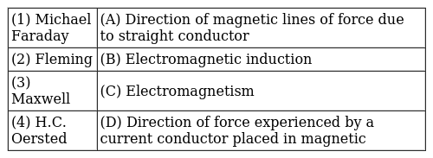  a) 1 - C, 2 - B, 3 - D, 4 - A  b) 1 - D, 2 - A, 3 - C, 4 - B  c) 1 - A, 2 - C, 3 - B, 4 - D  d) 1 - B, 2 - D, 3 - A, 4 - C | [1]
52 | Match the following with correct response. 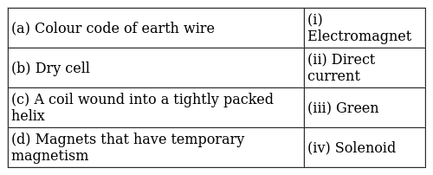  a) (a) - (i), (b) - (iii), (c) - (ii), (d) - (iv)  b) (a) - (iv), (b) - (i), (c) - (iii), (d) - (ii)  c) (a) - (iii), (b) - (ii), (c) - (iv), (d) - (i)  d) (a) - (ii), (b) - (iv), (c) - (i), (d) - (iii) | [1]
53 | Match the following with correct response. 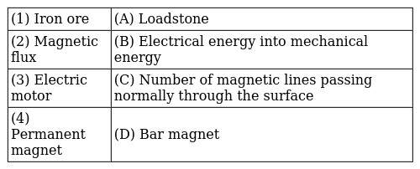  a) 1 - A, 2 - C, 3 - B, 4 - D  b) 1 - B, 2 - D, 3 - A, 4 - C  c) 1 - C, 2 - B, 3 - D, 4 - A  d) 1 - D, 2 - A, 3 - C, 4 - B | [1]
54 | Match the following with correct response. 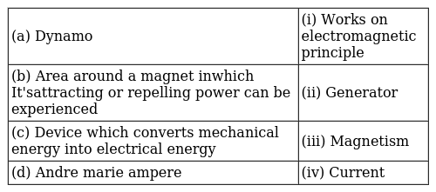  a) (a) - (iv), (b) - (i), (c) - (iii), (d) - (ii)  b) (a) - (ii), (b) - (iv), (c) - (i), (d) - (iii)  c) (a) - (i), (b) - (iii), (c) - (ii), (d) - (iv)  d) (a) - (iii), (b) - (ii), (c) - (iv), (d) - (i) | [1]
55 | Match the following with correct response. 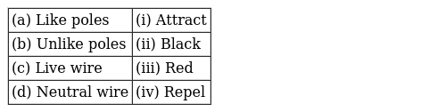  a) (a) - (iii), (b) - (ii), (c) - (iv), (d) - (i)  b) (a) - (i), (b) - (iii), (c) - (ii), (d) - (iv)  c) (a) - (ii), (b) - (iv), (c) - (i), (d) - (iii)  d) (a) - (iv), (b) - (i), (c) - (iii), (d) - (ii) | [1]
 | Section D
56 | The magnetic axis of earth makes an angle of _________ with geographic axis of earth.  a) 16$​^{o}$  b) 17$​^{o}$  c) 20$​^{o}$  d) 18$​^{o}$ | [1]
57 | The magnetic field lines inside a long current - carrying solenoid are nearly ________.  a) Straight  b) Elliptical  c) Parabolic  d) Circular | [1]
58 | When the main switch of the house circuit is put off, it disconnects the _________  a) Earth wire  b) Live wire  c) Live wire and Neutral wire  d) None of these | [1]
 | Section E
59 | Read the Case study followed by 3 questions Part (i)and (ii) are compulsory. However, an internal choice has been provided in part (iii): A magnetic field is described by drawing the magnetic field lines. When a small north magnetic pole is placed in the magnetic field created by a magnet, it will experience a force. And if the north pole is free, it will move under the influence of the magnetic field. The path traced by a north magnetic pole free to move under the influence of a magnetic field is called a magnetic field line. 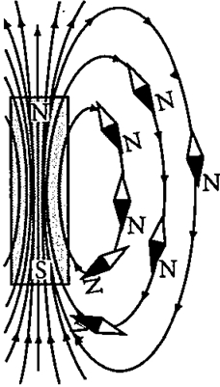  Since the direction of magnetic field line is the direction of force on a north pole, so the magnetic field lines always begin from the N - pole of a magnet and end on the S - pole of the magnet. Inside the magnet, however the direction of magnetic field lines is from the S - pole of the magnet to the N - pole of the magnet. Thus, the magnetic field lines are closed curves. When a small compass is moved along a magnetic field line, the compass needle always sets itself along the line tangential to it. So, a line drawn from the south pole of the compass needle to its north pole indicates the direction of the magnetic field at that point.  - Do the magnetic field lines intersect? if not why?  - A strong bar magnet is placed vertically above a horizontal wooden board. What would be the magnetic lines of force?  - Where dowe use Magnetic field lines?  - OR  - Draw the pattern of magnetic field lines for a bar magnet. | [4]
60 | Read the Case study followed by 3 questions Part (i)and (ii) are compulsory. However, an internal choice has been provided in part (iii): An insulated copper wire wound on a cylindrical cardboard tube such that its length is greater than its diameter is called a solenoid. When an electric current is passed through the solenoid, it produces a magnetic field around it. The magnetic field produced by a current - carrying solenoid is similar to the magnetic field produced by a bar magnet. The field lines inside the solenoid are in the form of parallel straight lines. The strong magnetic field produced inside a current - carrying solenoid can be used to magnetise a piece of magnetic material like soft iron, when placed inside the solenoid. The strength of magnetic field produced by a current carrying solenoid is directly proportional to the number of turns and strength of current in the solenoid.  - What would be the strength of the magnetic field inside a long current - carrying straight solenoid?  - By using which rule we can find the north - south polarities of an electromagnet?  - A long solenoid carrying a current produces a magnetic field B along its axis. If the current is double and the number of turns per cm is halved, then what will be the new value of magnetic field?  - OR  - A soft iron bar is enclosed by a coil of insulated copper wire as shown in figure. When the plug of the key is closed, then where would the face B of the iron bar be marked?  - 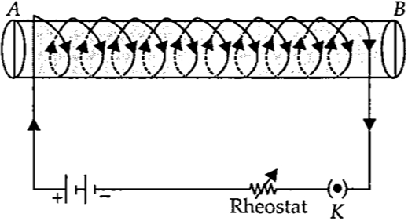 | [4]
61 | Read the Case study followed by 3 questions Part (i)and (ii) are compulsory. However, an internal choice has been provided in part (iii): A current carrying wire produces magnetic field around it. The phenomena in which an electromotive force and current (if the conductor is in the form of a closed circuit) is induced by changing magnetic field (or by passing magnetic field lines) through it is called electromagnetic induction. The emf so developed is called induced emf and current made to flow is called induced current. 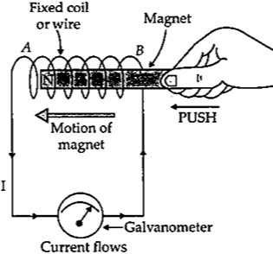  The cause of induced emf carried out by Faraday and Henry. It can be concluded that the induced current flows in a conductor as long as the magnetic lines of force change within the conductor. In case of relative motion i.e., motion of coil w.r.t to magnet or vice versa, the direction of the current flowing in the conductor is determined by the direction of the relative motion of the conductor with respect to the magnetic field. The induced emf or current is directly proportional to the rate of change in magnetic field.  - A student connects a coil of wire with a sensitive galvanometer as shown in the figure. Where will he observe the deflection in the galvanometer ofbar magnet? 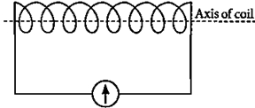  - A conducting rod AB moves across two magnets as shown in the figure and the needle in the galvanometer deflects momentarily. What is the name of this physical phenomenon? 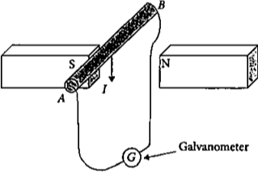  - A bar magnet is pushed steadily into a long solenoid connected to a sensitive meter. 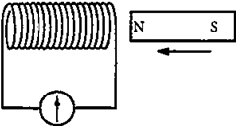  - What would affect the magnitude of the deflection of the meter?  - OR  - An induced emf is produced when a magnet is plunged into a coil. on which factor/factors does the magnitude of induced emfdepend? | [4]
62 | Read the Case study followed by 3 questions Part (i)and (ii) are compulsory. However, an internal choice has been provided in part (iii): Andre Marie Ampere suggested that a magnet must exert an equal and opposite force on a current carrying conductor, which was experimentally found to be true. But we know that current is due to charges in motion. Thus, it is clear that a charge moving in a magnetic field experience a force, except when it is moving in a direction parallel to it. If the direction of motion is perpendicular to the direction of magnetic field, the magnitude of force experienced depends on the charge, velocity (v), strength of magnetic field (B), and sine of the angle between v and B. Direction of magnetic force is given by Fleming’s left hand rule. 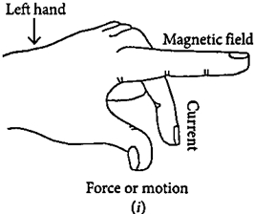  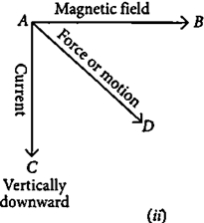  - If an electron is travelling horizontally towards east. A magnetic field in vertically downward direction exerts a force on the electron along which direction?  - If a charged particle is moving along a magnetic field line. Then What would be themagnetic force on the particle?  - A uniform magnetic field exists in the plane of paper pointing from left to right as shown in figure. In the field, an electron and a proton move as shown. Where do theelectron and the proton experience the force? 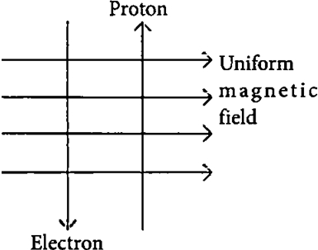  - OR  - An electron beam enters a magnetic field at right angles to it as shown in the figure. What would be the direction of force acting on the electron beam?  - 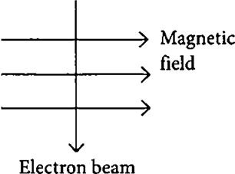 | [4]

